1. Write a simple "Hello World" program in two different programming languages of your choice. Compare the structure and syntax.

Ans:- File Attached.

1. Research and create a diagram of how data is transmitted from a client to a server over the internet.

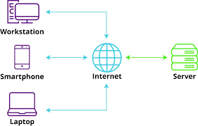

|  |  |  |
| --- | --- | --- |
| **Types of internets** | **Pros.** | **cons.** |
| Broadband (Cable and DSL) | Widely | Speed fluctuation |
| Relatively fast speeds | Shared bandwidth |
| Cost-effective | Speed depends on server Distance |
| Fibre optic | Fast speed | Installation cost high |
|  | High bandwidth | Limited availability |
|  | Reliable connection | Difficult to Repair |
| Satellite Internet | Access in remote locations | Weather can affect connection |
|  | Wide coverage Area | High cost compared to other |

1. Research different types of internet connections (e.g., broadband, fibre, satellite) and list their pros and cons.
2. Identify and classify 5 applications you use daily as either system software or application software.

|  |  |  |
| --- | --- | --- |
| **Parameter** | **System Software** | **Application Software** |
| Functionality | Designed to run computer’s hardware and application software & resource allocation, memory management in Hardware. | Designed to perform specific task tailored to meet user needs such as productivity, creativity, entertainment, etc. |
| Examples | Windows, MacOS, Chrome OS, iOS, Android, etc. | Chrome, Safari, Firefox, Spotify, Slack, Skype, Microsoft office, Excel, PowerPoint, Zoom, Apple Music, etc |

1. Design a basic three-tier software architecture diagram for a web application

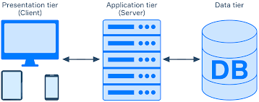

1. Create a case study on the functionality of the presentation, business logic, and data access layers of a given software system.

Presentation: - The layer at which users interact with the application and the final data will be visible to the users at this interface. It acts as an interface between the user and the application.

Business Logic: - It acts as an intermediate between the presentation layer & Data Access layer.

Data Access Layers: - The layer at which data is Managed.

1. Explore different types of software environments (development, testing, production). Set up a basic environment in a virtual machine.

Performance Testing Environment.

System integration Testing (SIT)

User Acceptance Testing (UAT)

Quality Assurance (QA)

Security Testing

Chaos Testing

Alpha Testing

Beta Testing.

1. Write and upload your first source code file to Github.

Ans:- Created and Upload done.

1. Create a Github repository and document how to commit and push code changes?

Ans:- Done

1. Create a list of software you use regularly and classify them into the following categories: system, application, and utility software.

|  |  |  |
| --- | --- | --- |
| System | Application | Utility |
| OS | Multimedia app | Antivirus |
| Window | education app | file management system |
| Linux | Presentation App | Disk Management tools |
| Database | Web browser | Compression tools |
| Device Drivers | Project Management | Disk cleanup tool |
| Firmware | Graphic software | Backup utility |
| Android | Enterprise Software | Disk Defragmenter |

1. Write a report on the various types of application software and how they improve Productivity.

Word Processing Software. ...

Spreadsheet Software. ...

Presentation Software. ...

Multimedia Software. ...

Web Browsers. ...

Educational Software. ...

Graphics Software. ...

Freeware.

Application Software Have a Special Function for easy to work & improve productivity.

1. Create a flowchart representing the Software Development Life Cycle (SDLC).

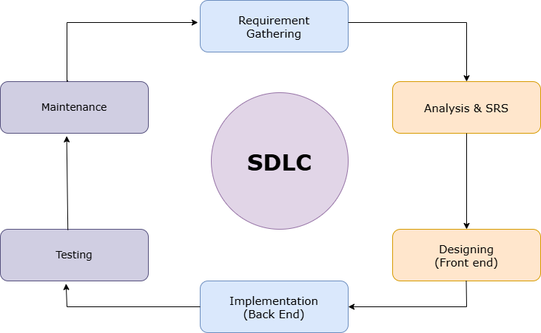

1. Write a requirement specification for a simple library management system.

Store Information about Each Book. (Title, Author, Genre, Publication Date)

Track Availability (Copies Qnty, Current Status).

Categorize book into Categories for easy Classification.

Allow the librarian to add or remove Members.

1. Perform a functional analysis for an online shopping system.

User Registration & Login

Product catalogue & Search

Shopping cart & Payment checkout

Order Management & Tracking.

Seles Analytics and Reporting

Security and compliance

1. Design a basic system architecture for a food delivery app.

Customer Application: - Its main features Are below

Menu view, Restaurant list, Payments, Tracking, Review & Rating, Promo codes & Discount, view order History, Notification, User Profile.

Restaurant Application: - Its main features are Below

Order Management, Menu Update, Order confirmation/Rejection, Tracking, profile Management, Customer Feedback & Support.

Rider Application: - Its main features are Below

Order acceptance/ Rejection, Order Details, Navigation, Notification, Customer Feedback, order History.

Administration: - its main features are Below

User Management, Restaurant management, Rider Management, Content Management, Analytic & Reporting.

1. Create a DFD for a hospital management system.

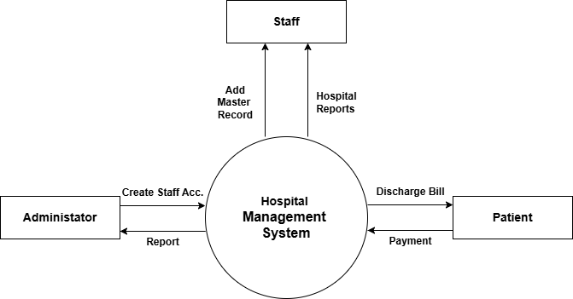

1. Draw a flowchart representing the logic of a basic online registration system

